PHYS1401 Final Exam Version 2 (105/100 pts)
NOTE(IMPORTANT!!): Please detach, sign, and submit the equation sheet to receive credit.
Print Name:__________________________________________________________________________
Student ID:________________________ Course Section:_____________________________________

Part I: Multiple-choice Questions (Only the answer shall be credited. Each question has only one correct answer.)
- (5pts) Which of the diagrams below shows a correct right-hand 3D coordinate system (i.e., $\hat{x}×\hat{y}=\hat{z}$)?
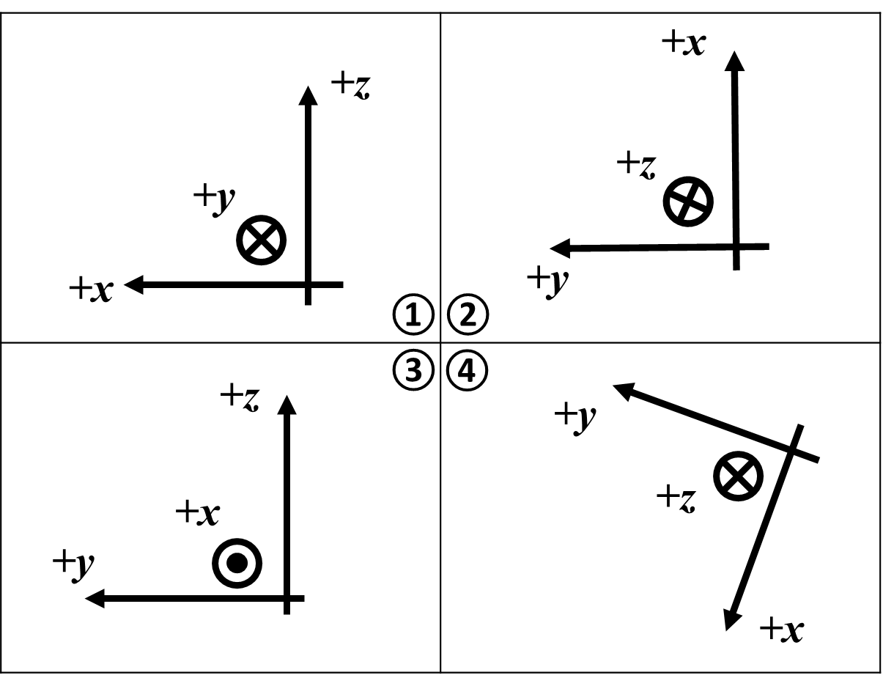
- ①
- ②
- ③
- ④

- (5pts) A girl is at the carnival and rides the Merry-Go-Round. The ride moves with a constant angular velocity $ω=1.5$ rad/s. As the ride comes to an end, a constant angular acceleration of $α=-0.3$ rad/s² is applied. How long does it take for the Merry-Go-Round to come to a stop?
- 3 s
- 4 s
- 5 s
- 6 s

- (5pts) Two forces, F₁ and F₂ are applied to a wrench to exert torque on a nut (point N) at different distances and angles. Considering the torque equation $\vec{τ}=\vec{r}×\vec{F}$ for evaluating the torque on the nut due to ${\vec{F}}_{2}$, which of the following diagrams shows the correct position vector $\vec{r}$?
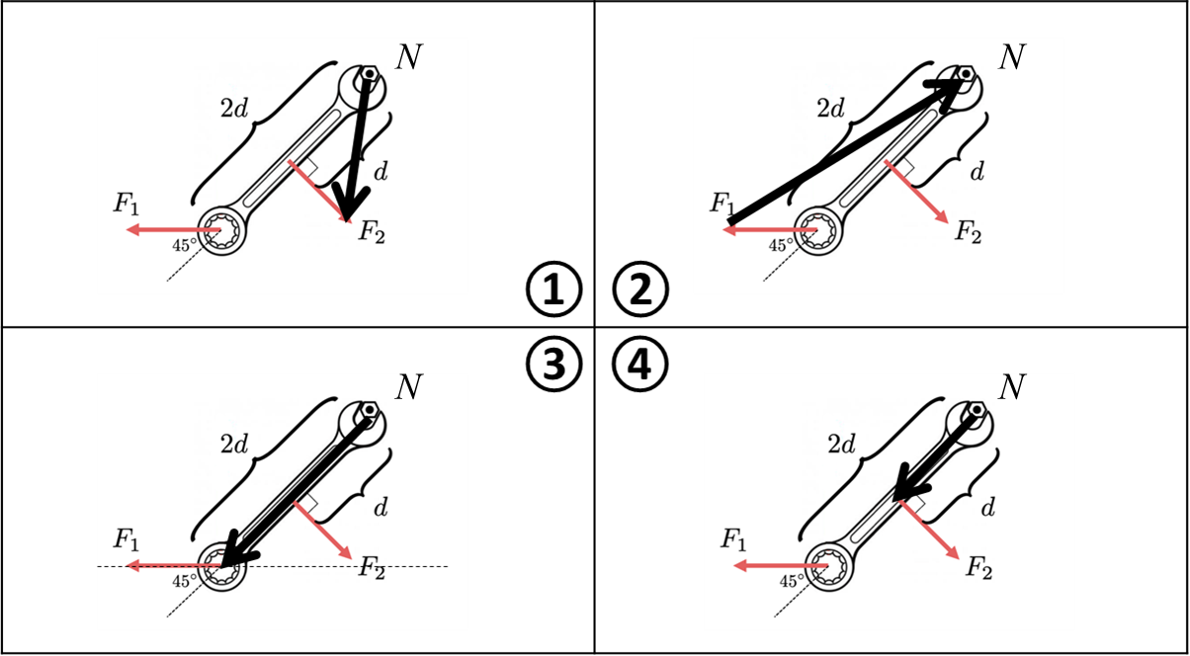
- ①
- ②
- ③
- ④

- (5pts) A uniform disk is pulled by a force F through a string attached to its center of mass. The disk rolls smoothly without slipping on a horizontal tabletop. Which of the following statements is correct regarding its rotational motion?

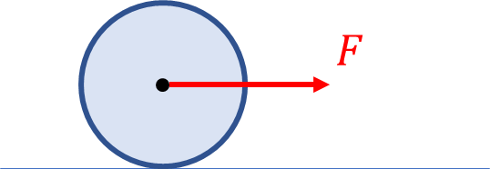

- The torque applied to the center of the disk due to the normal force is zero.
- The frictional force is negligible.
- The torque around the center of the disk due to the force F is not zero.
- The torque around the center of the disk due to the normal force is not zero.

- (5pts) A solid cylinder has a mass M and radius R. The moment of inertia about its symmetrical axis is $\frac{1}{2}MR^{2}$. What is the moment of inertia of the cylinder about a parallel axis that lies on the surface of the cylinder?
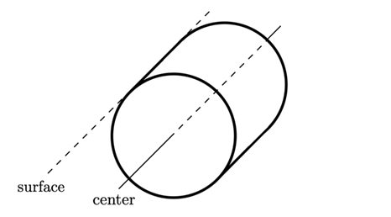
  - $\frac{5}{2}MR^{2}$
  - $\frac{3}{2}MR^{2}$
  - $MR^{2}$
  - $\frac{1}{2}MR^{2}$

- (5pts) Two small square masses are connected to a massless rod. The whole configuration is rotating with a constant angular velocity $ω$. What is the kinetic energy of the system?
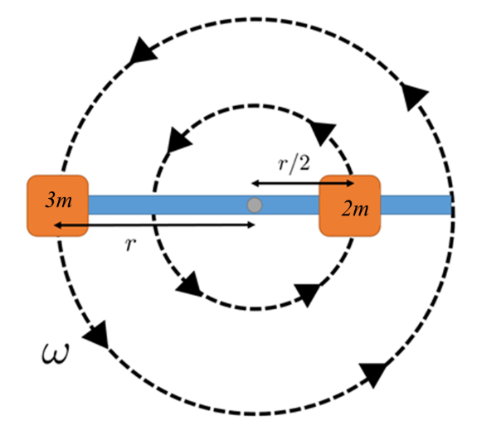
- $\frac{9}{8}mr^{2}ω^{2}$
- $5mr^{2}ω^{2}$
- $\frac{4}{3}mr^{2}ω^{2}$
- $\frac{7}{4}mr^{2}ω^{2}$

- (5pts) A physics professor is standing on a frictionless rotating stool. The angular velocity is changed from $ω_{1}$ to $ω_{2}$ as he moves his arms closer to his chest. Which of the following statements is correct regarding the professor + stool system?
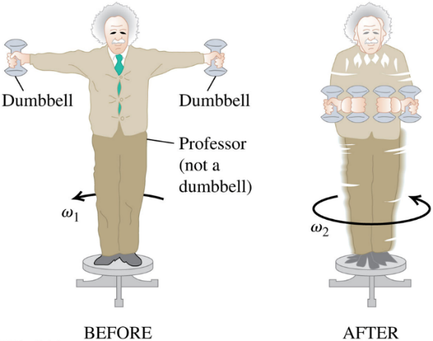
- $ω_{1}=ω_{2}$
- The moment of inertia does not change.
- The angular momentum does not change.
- The angular momentum increases.

- The diagram shows four particles (labeled 1, 2, 3, and 4) moving in the x-y plane. Particle 1 is located at (-4 m, 2 m) and is traveling in the positive x-direction. Particle 2 is positioned at (4 m, 3 m) and is moving in the negative x-direction. Particle 3 is at (0 m, -3 m) and is moving in the positive y-direction. Particle 4 is located at (5 m, -3 m) and has a velocity that makes an angle of 45 degrees with the coordinate axes. Which particle(s) have an angular momentum about the origin with a direction pointing into the page?
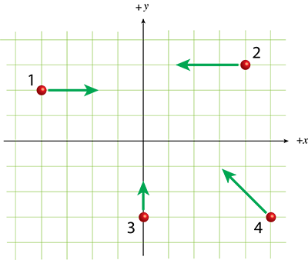

- Particle 1.
- Particles 2 and 4.
- Particle 3.
- None of the above.

Questions 9-10 are based on the following scenario: Two blocks on a horizontal, frictionless track are moving toward each other, as shown. Assume the collision between the blocks is perfectly elastic.
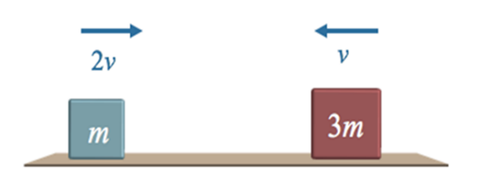
- (5pts) What is the velocity of the center of mass of the two-block system?
- 0
- v to the left
- v to the right
- v/4 to the left

- (5pts) In the center of mass reference frame, what is the velocity of the right block after the collision?
- 9v/4 to the left
- 9v/4 to the right
- 3v/4 to the left
- 3v/4 to the right

Part II: Problem-solving Question (Please present the complete problem-solving procedure. Answers with no supportive calculation shall not be credited)
- (15pts) A 510 g disk with a radius of 12 cm is supported by a pivot through its center. It is initially at rest then experiences a constant angular acceleration for 15 seconds, at the end of which it is spinning with a frequency of 85 revolutions per minute.
  - (10pts) Calculate the magnitude of the angular velocity of the disk in radians per second at time t = 15 seconds.

  - (5pts) Calculate the magnitude of the net torque on the disk.

- (20pts) A uniform disk with a radius of 4.3 cm and a mass of 270 g is released from rest on a ramp inclined at an angle 25° above the horizontal. The disk rolls without slipping, as shown in the diagram. Using the five-step problem-solving procedure, determine both the direction and magnitude of the frictional force exerted on the disk. As part of the solution, include a free-body diagram illustrating all forces acting on the disk.
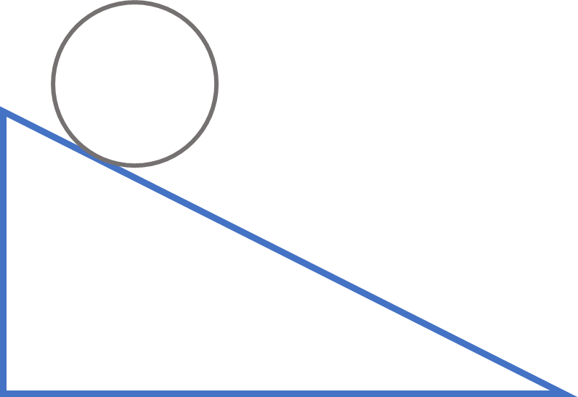

- (20pts) A rod of length L and mass m is securely anchored at its center on a horizontal tabletop and can rotate freely about its central axis (as shown in the top-down view below). A force F is applied at the right end of the rod to induce rotational motion.

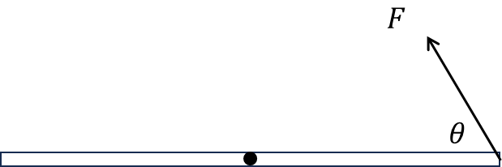

- (5pts) Using the variables L, F, and $θ$, derive an expression for the magnitude of the net torque.

- (5pts) Determine the direction of the net torque.

- (10pts) Assuming the net torque remains constant for a time t, find the magnitude of the final angular velocity of the rod starting from rest. Use the variables m, L, F, t, and $θ$ to derive an expression for your answer.

Equation Sheet

Gravitational acceleration: g = 9.8 m/s²

Moment of inertia: $I=\sum{m_{i}r_{i}^{2}}$
The parallel-axis theorem: $I_{Total}=I_{CM}+{Md}^{2}$
Torque: $\vec{τ}=\vec{r}×\vec{F}$
Torque magnitude: $\left|\vec{τ}\right|=\left|\vec{r}×\vec{F}\right|=\left|\vec{r}\right|\left|\vec{F}\right|\sin{θ}$
Angular quantities: $s=Rθ$, $v=Rω$, $a=Rα$

Translational/Linear dynamics: $\sum{\vec{F}=m\vec{a}}$
Rotational dynamics: $\sum{\vec{τ}}=I\vec{α}$

The following four equations could also be applied to other directions, with a proper subscript modification:
1D constant linear acceleration motion: $v_{x}=v_{0x}+a_{x}t$ and $x=x_{0}+v_{0x}t+\frac{1}{2}a_{x}t^{2}$
Constant angular acceleration motion: $ω_{z}=ω_{0z}+α_{z}t$ and $θ_{z}=θ_{0z}+ω_{0z}t+\frac{1}{2}α_{z}t^{2}$

Translational/Linear kinetic energy: ${KE}_{T}=\frac{1}{2}mv^{2}$
Rotational kinetic energy: ${KE}_{R}=\frac{1}{2}Iω^{2}$

Angular momentum of a particle: $\vec{L}=\vec{r}×\vec{p}=\vec{r}×m\vec{v}$
Angular momentum of a rigid body: $\vec{L}=I\vec{ω}$
Torque and angular momentum: $\sum{\vec{τ}}=\frac{d\vec{L}}{dt}$

Position vector of center of mass: ${\vec{r}}_{cm}=\frac{\sum_{i}{m_{i}{\vec{r}}_{i}}}{\sum_{i}{m_{i}}}$
Velocity of center of mass: ${\vec{V}}_{cm}=\frac{\sum_{i}{m_{i}{\vec{V}}_{i}}}{\sum_{i}{m_{i}}}$
Relative motion: ${\vec{V}}_{A,B}={\vec{V}}_{A,C}+{\vec{V}}_{C,B}$ and ${\vec{V}}_{A,B}=-{\vec{V}}_{B,A}$

Momentum: $\vec{p}=m\vec{v}$
Momentum conservation: $\sum{{\vec{p}}_{i}}=\sum{{\vec{p}}_{f}}$



